Lab Report | Redis Key–Value Store: TicketRush

1. Objective
Implement and evaluate Redis primitives for a concurrent ticketing prototype: atomic seat holds, confirmed sales, general-admission inventory, rate limiting, virtual queues, and cache-aside. Demonstrate the results using reproducible tests and compare appropriate data structures.

2. Environment and methodology
Component | Observed setup
Python | 3.14.7
Docker / Compose | 29.9.2 / v5.6.1
Redis server | redis:8 container on localhost:6379
Redis Python client | redis-py 8.1.0
Test program | ticketrush.py; ThreadPoolExecutor for concurrent workers
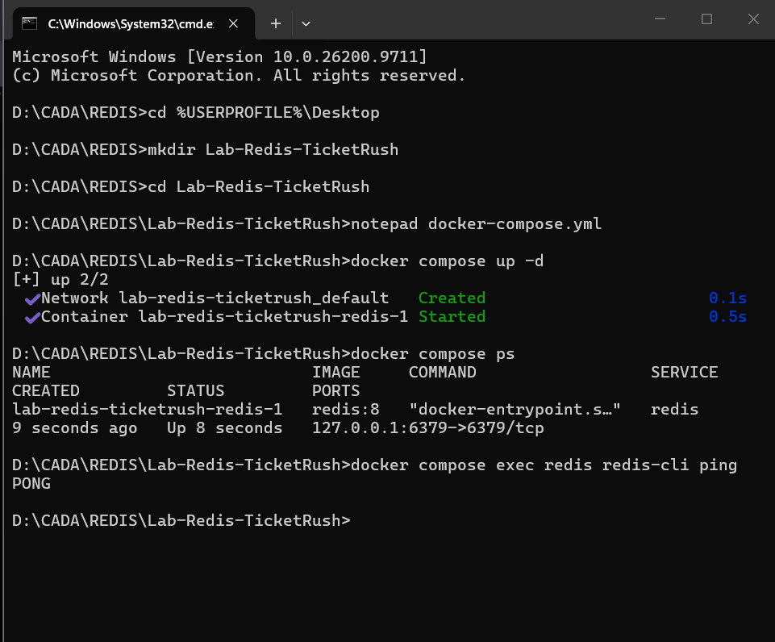
Figure 1. Docker container and successful Redis PING / PONG.
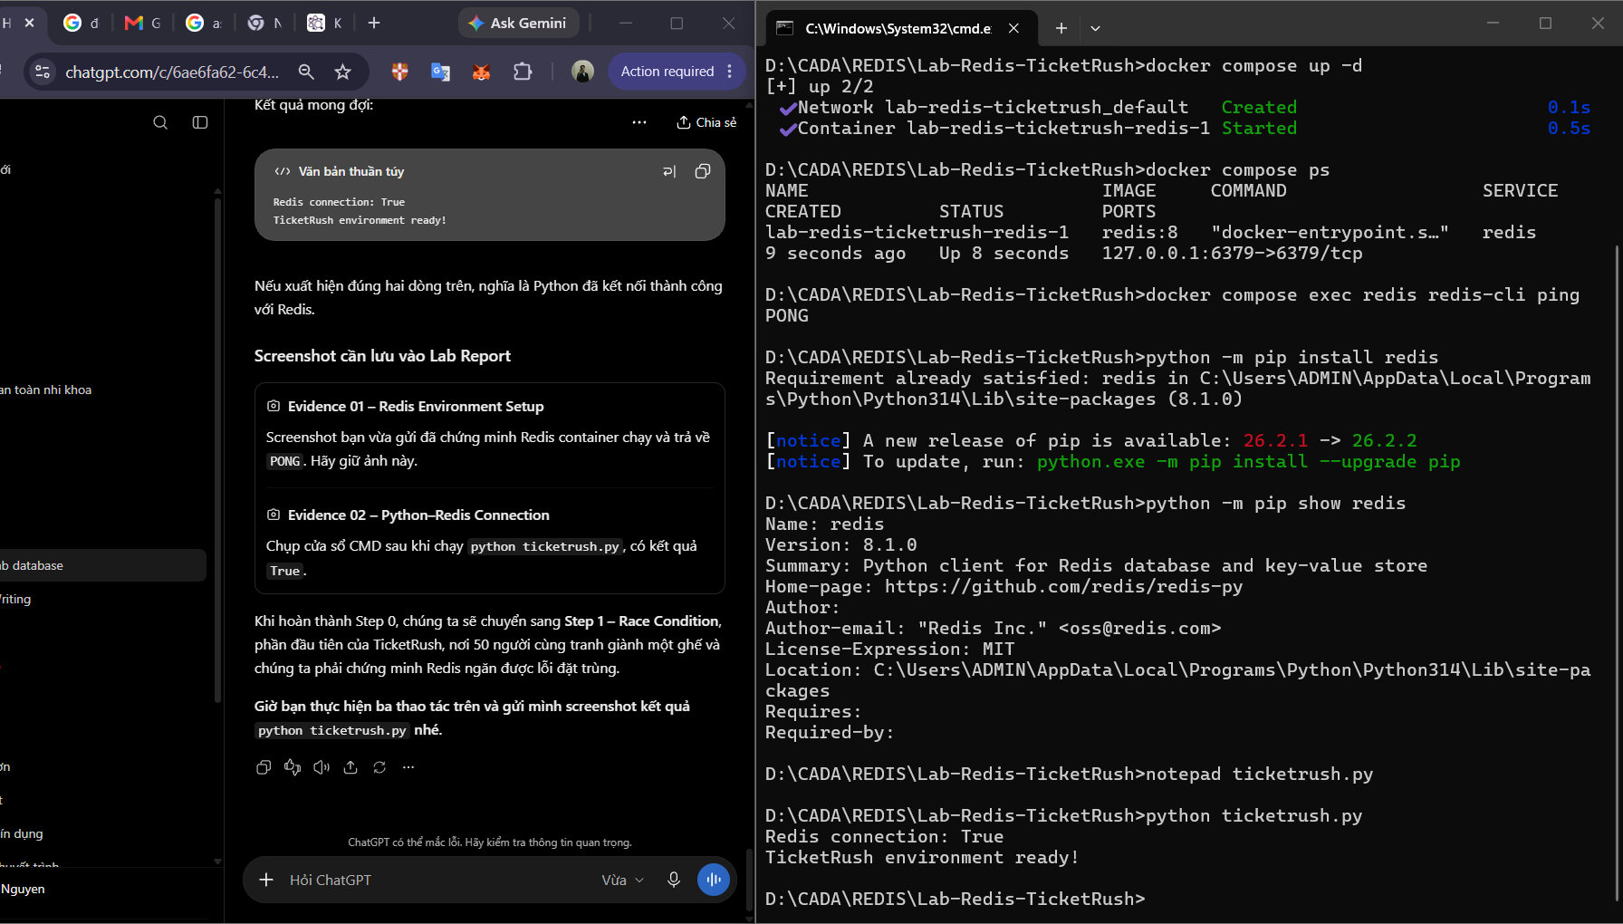
Figure 2. redis-py installation and successful Python–Redis ping.

3. Implementation and observed results

3.1 Step 1 — Race condition
Two approaches were compared for 50 concurrent attempts on seat A1. The naïve GET-then-SET sequence permits multiple clients to observe a vacant seat before any SET completes; one captured run reported 11 winners. SET NX EX combines conditional write and expiration into a single Redis operation; it reported exactly one winner with TTL 300 s.
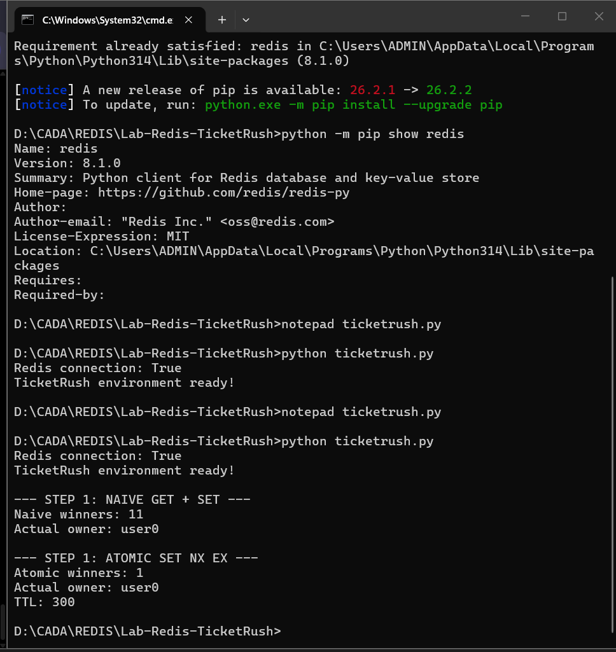
Figure 3. Naïve concurrent hold vs. atomic SET NX EX.

3.2 Step 2 — Atomic hold, confirm and release
Lua scripts enforce ownership checks and sold-seat membership. Linh held A1; Nam could neither hold nor confirm it; Linh confirmed it; and a sold A1 could not be held again. For A2, an unauthorized release failed and the owner successfully released it. Final map: A1 sold, A2 free.
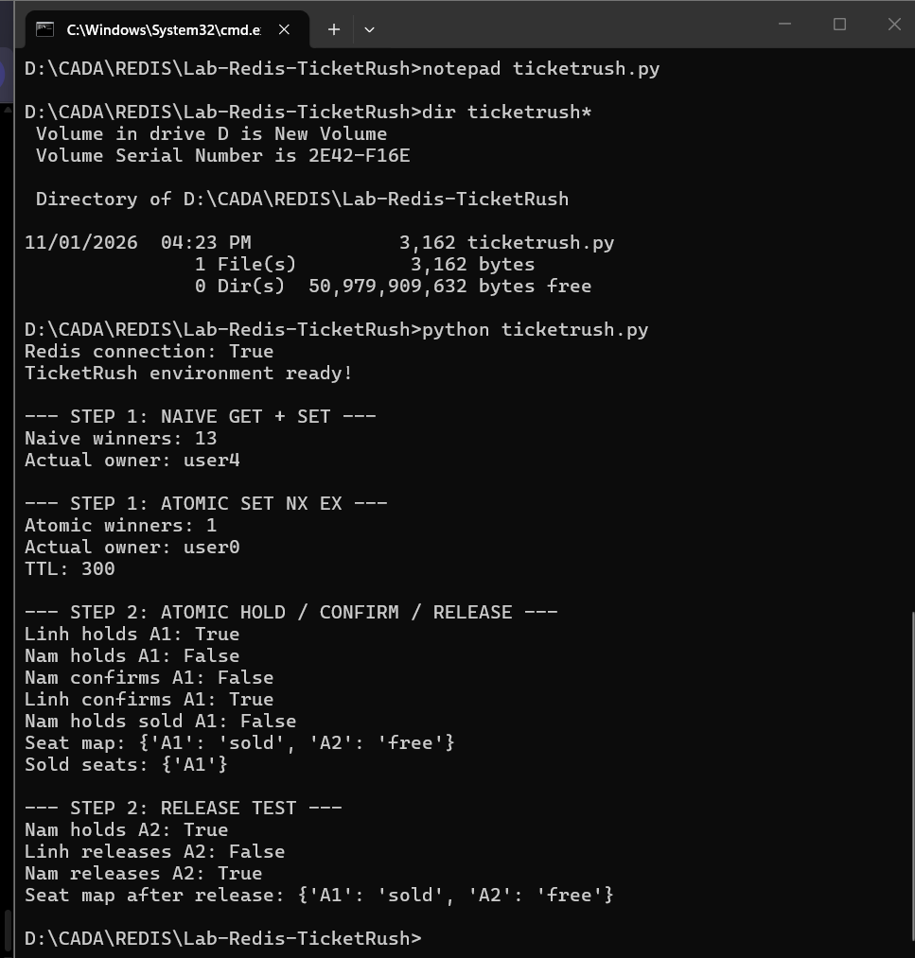
Figure 4. Successful ownership and sold-seat tests.

3.3 Step 3 — General-admission flash sale
A stock counter started at 100 and 500 threaded buyers called DECR; negative results were compensated by INCR. In the observed test, 100 requests succeeded, stock ended at zero, and the buyers set contained 100 unique IDs. This test supports no overselling in this run, but the multi-command purchase path is not transactionally atomic.
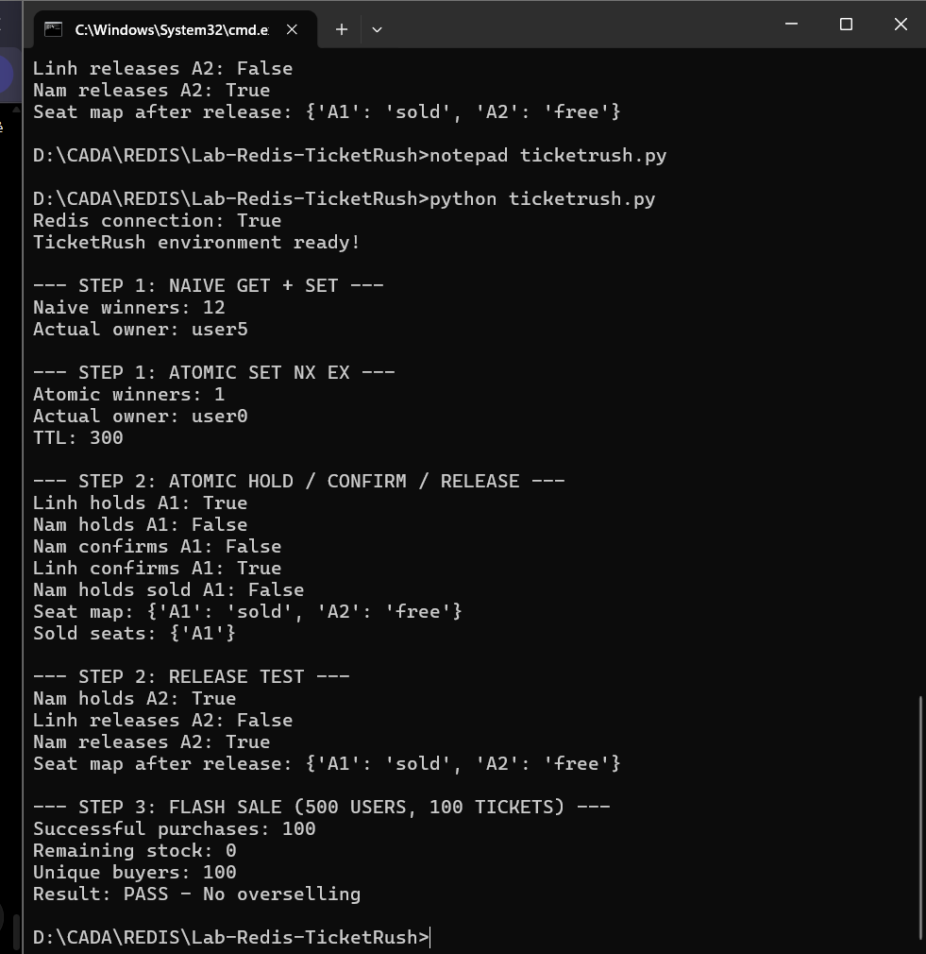
Figure 5. Flash-sale results: 100 purchases; 0 remaining stock.

3.4 Step 4 — Fixed and sliding rate limits
For a short burst of eight requests, both variants allowed five and denied three. The sliding-window limiter uses a sorted set of per-request unique IDs and a Lua script to prune, count and insert atomically. The hold endpoint subsequently returned five ok results and three rate_limited responses. No measured boundary-burst comparison was performed.
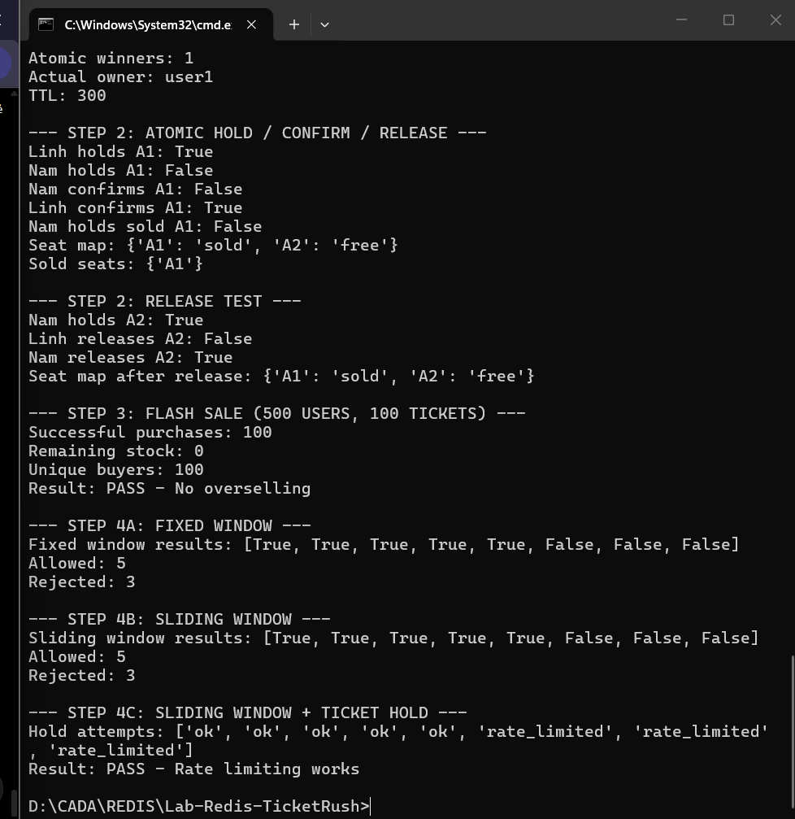
Figure 6. Rate-limit results in CMD.

3.5 Step 5 — Virtual waiting room
A sorted set stores queue-entry timestamps as scores. Users u1, u2 and u3 joined at ranks 1, 2 and 3. Rejoining did not change u1’s rank. The first two users were admitted, and u3 became rank 1. A small delay between joins avoids indistinguishable timestamp scores in this demo.
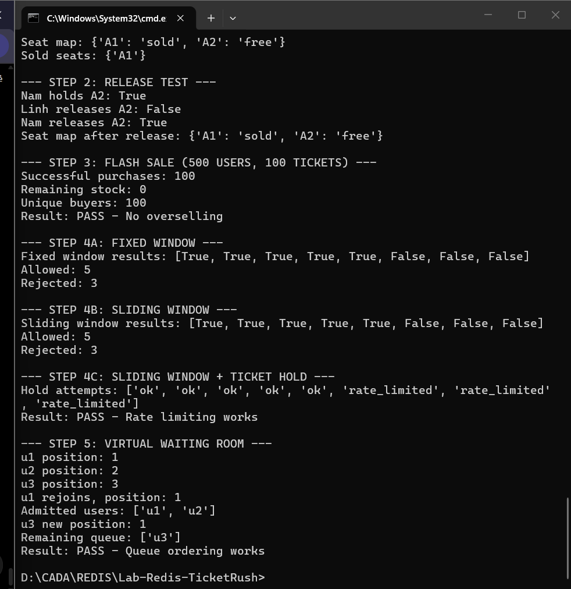
Figure 7. Queue order, rejoin and admission.

3.6 Step 6 — Concurrency stress test
One hundred threads competed for 20 numbered seats and confirmed their reservations after a small randomized delay. The test was repeated ten times, resetting Redis between runs. For every run: successful sales = 20; distinct seat IDs = 20; Redis sold-set cardinality = 20.
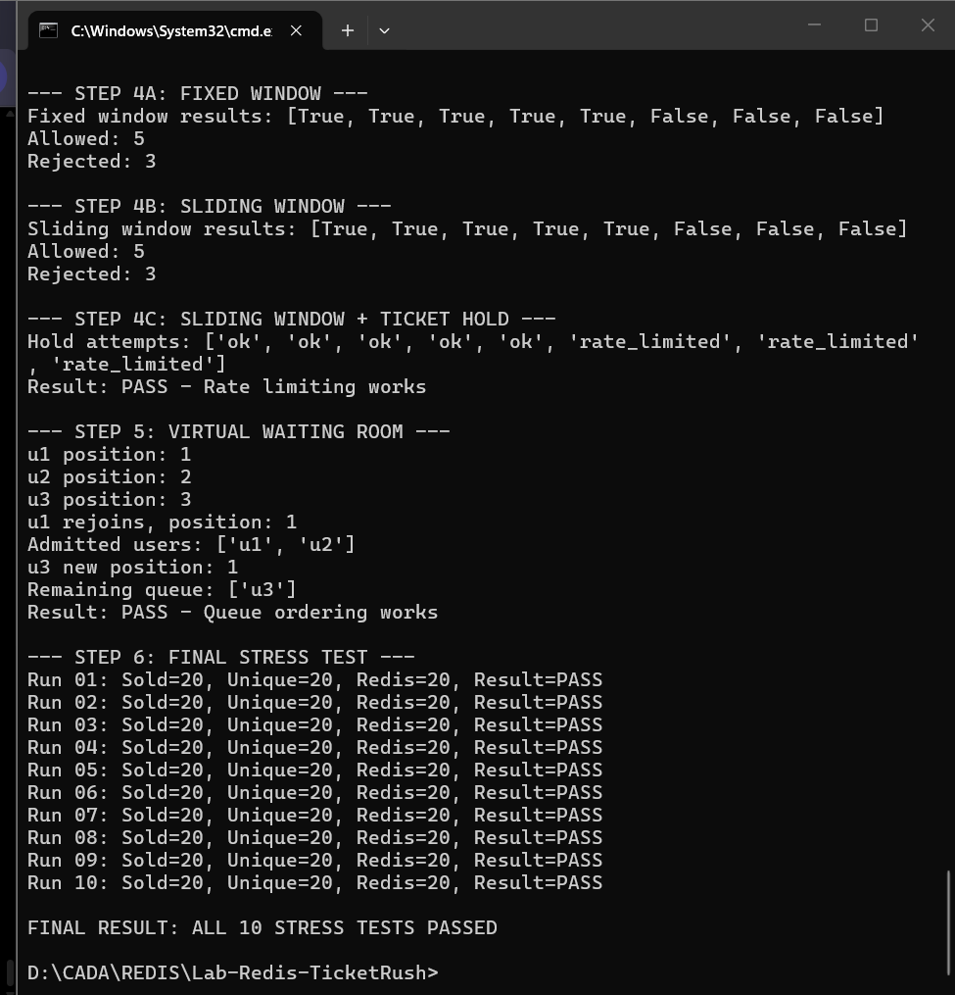
Figure 8. All 10 stress-test rounds passed.

3.7 Exercise A — Sorted-set leaderboard
Scores for five players were loaded into one sorted set. Descending Top 3 was Mai (1430), Linh (1200), and An (1100). ZREVRANGE and ZREVRANK returned the expected ordering and positions.
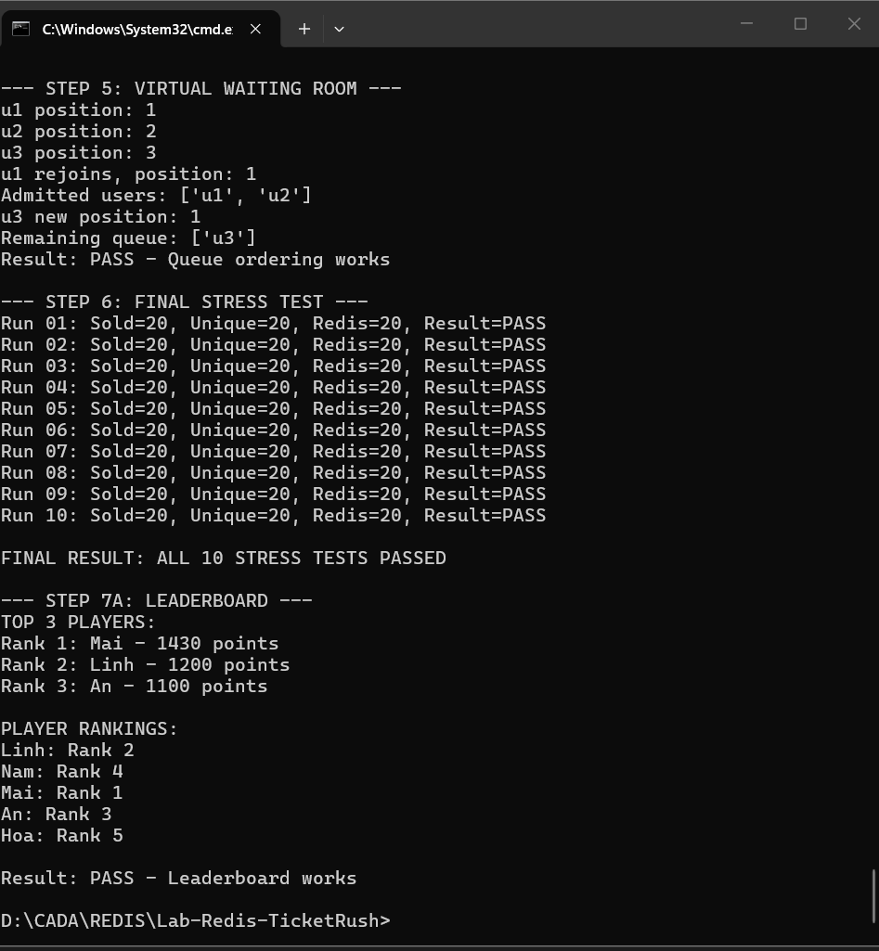
Figure 9. Leaderboard and individual ranks.

3.8 Exercise B — User hashes and city indexing
User profiles were stored in Redis hashes, while per-city sets indexed user IDs. The query for Hanoi returned IDs 101, 103 and 105 (three users). A city change requires updating both the profile and the related sets to preserve index consistency.
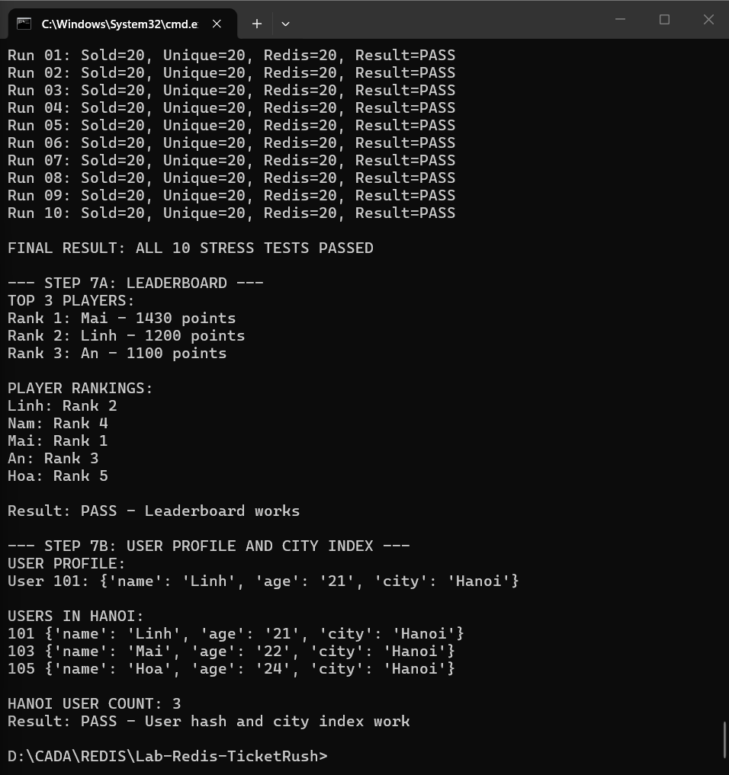
Figure 10. User profiles and city-based secondary index.

3.9 Exercise C — Cache-aside benchmark
A simulated source query sleeps for 10 ms, representing a slow database call. Across 100 sequential calls, the uncached case took 1.0418 s; the cached case took 0.0870 s (11.98× faster). The cached product was Python Basics and TTL was 300 s. The cache test includes one miss followed by hits. These timings do not benchmark a real relational database.
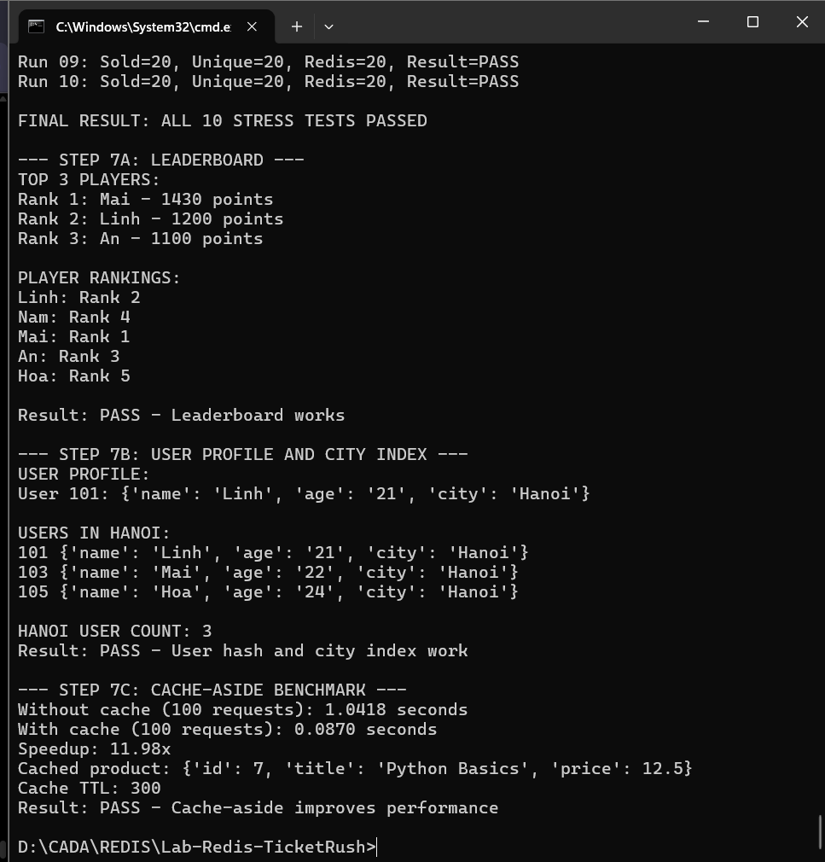
Figure 11. Cache-aside performance measured in CMD.

4. Answers to the five report questions

Q1. Why does SET NX EX avoid the race that GET followed by SET does not?
GET and SET are separate operations, allowing another client to intervene between reading and writing. SET key value NX EX ttl checks that the key does not exist, writes the key, and attaches a TTL in one atomic Redis command. Only one competing client can acquire an initially absent key.

Q2. What happens if the customer closes the browser after holding a seat?
The hold key remains temporarily, even if the browser disappears. Its TTL expires automatically after the configured interval (300 s in this lab), allowing the seat to become available again unless it has already been confirmed sold. Expiration is managed by Redis, not by the browser.

Q3. What goes wrong if CONFIRM does not verify the hold owner?
A different customer could confirm a seat held by somebody else, or a stale confirmation could act on a seat subsequently acquired by another customer. Checking that the hold value equals the confirming user in the same atomic Lua script prevents this unauthorized state change in the demo.

Q4. Why is a fixed window vulnerable at its boundary, and how does sliding window help?
Five allowed requests at the end of one fixed 10-second interval plus five at the beginning of the next can admit ten requests in a very short real-time span. A sliding window checks the actual preceding 10-second interval for every request, so the two bursts still share one rolling quota. The student demonstrated five of eight allowed for each method, but did not separately measure the boundary scenario.

Q5. What must still be stored in a durable database, and when?
Redis is useful for temporary holds, availability counters, throttling and queue state. Confirmed purchases, user identity, payment records, ticket entitlements and an auditable order status need a durable source of truth (for example PostgreSQL). The system should only finalize a sale after a verified payment and durable, idempotent order transaction. The Redis confirmation and relational commit need carefully designed coordination; if Redis crashes after a confirmation but before durable recording, a sold seat may be lost from Redis without a corresponding durable order. Reconciliation, outbox/event handling and recovery procedures are needed to avoid that inconsistency.

5. Limitations and improvements
This is an instructional prototype. Tests demonstrate behavior for the displayed scenarios, not correctness under every failure mode. Additional production work would include atomic/idempotent stock purchase scripts, cross-store reconciliation, durable order persistence, robust sliding-window timing, queue fairness under timestamp ties, connection-failure handling, and reliable load-test metrics. Multiple FLUSHDB calls are safe only on a dedicated training database.

6. Conclusion
All recorded TicketRush demonstrations and three exercises achieved their specified outcomes on the student’s local setup. The stress test passed ten consecutive runs, and the simulated cache-aside workload showed an 11.98× speedup. The experiments illustrate Redis atomic commands, Lua scripts, expiry, hashes, sets and sorted sets, while highlighting why a persistent transaction database is still required for actual ticket purchase settlement.

